Question 1:- https://leetcode.com/problems/two-sum/
Solution: - https://leetcode.com/problems/two-sum/submissions/2007287771/
Screenshot:-
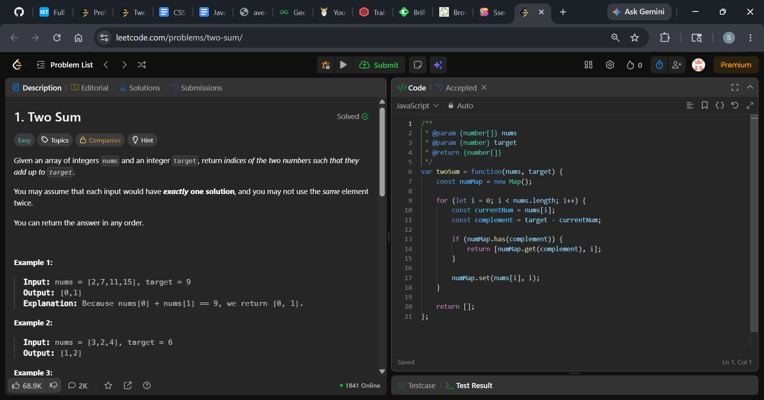
Description: -
- Time Complexity: O(n) — We iterate through the array of length n exactly once.
- Space Complexity: O(n) — In the worst-case scenario, we might store up to n elements in the hash map.
Explanation: -
The code uses a Hash Map (Map in JavaScript) to find the two indices in a single pass (O(n) time complexity). Instead of checking every possible pair with nested loops, it keeps track of the numbers it has already seen and looks for the "missing partner" (the complement).
Here is the breakdown of what happens step-by-step:

1. The Strategy: Looking for the Complement
For any number you are currently looking at, you know exactly what other number is required to reach the target.
Complement = target - current number
- Example: If target = 9 and your current number is 2, your complement is 9 - 2 = 7.
- The problem then becomes: "Have we seen a 7 earlier in the array?"

2. Line-by-Line Breakdown
const numMap = new Map();
- This initializes an empty Hash Map. It will store the numbers we encounter as keys and their array indices as values (e.g., {number: index}).
for (let i = 0; i < nums.length; i++) {
const complement = target - nums[i];
- We start a for loop to look at each number (nums[i]) one by one.
- We calculate the complement needed for the current number to reach the target.
JavaScript
if (numMap.has(complement)) {
return [numMap.get(complement), i];
}
- We check our map: "Is the complement already in our map?"
- If it is: It means we found the two numbers that add up to the target! We immediately return an array containing the index of the complement (numMap.get(complement)) and the current index (i).
JavaScript
numMap.set(nums[i], i);
}
- If it isn't in the map, we add the current number and its index to our map so that numbers further down the array can look it up.

3. Dry Run Example
Let's trace the code using Example 1: nums = [2, 7, 11, 15], target = 9.
- Loop 1 (i = 0):
  - Current number = 2
  - complement = 9 - 2 = 7
  - Is 7 in numMap? No (the map is empty).
  - Action: Add 2 to the map=>numMap = { 2: 0 }.
- Loop 2 (i = 1):
  - Current number = 7
  - complement = 9 - 7 = 2
  - Is 2 in numMap? Yes! Its stored index is 0.
  - Action: Return [0, 1]. The execution stops here.

Why this is highly efficient:
- Brute Force (O(n^2)): Compares every number with every other number using two loops.
- This Map Approach (O(n)): Only loops through the array once. Checking if a key exists inside a Map takes O(1) constant time on average, making it incredibly fast even for huge arrays.

Question 2:- https://leetcode.com/problems/count-number-of-pairs-with-absolute-difference-k/
Solution: - https://leetcode.com/problems/count-number-of-pairs-with-absolute-difference-k/submissions/2008814422/
Screenshot:-
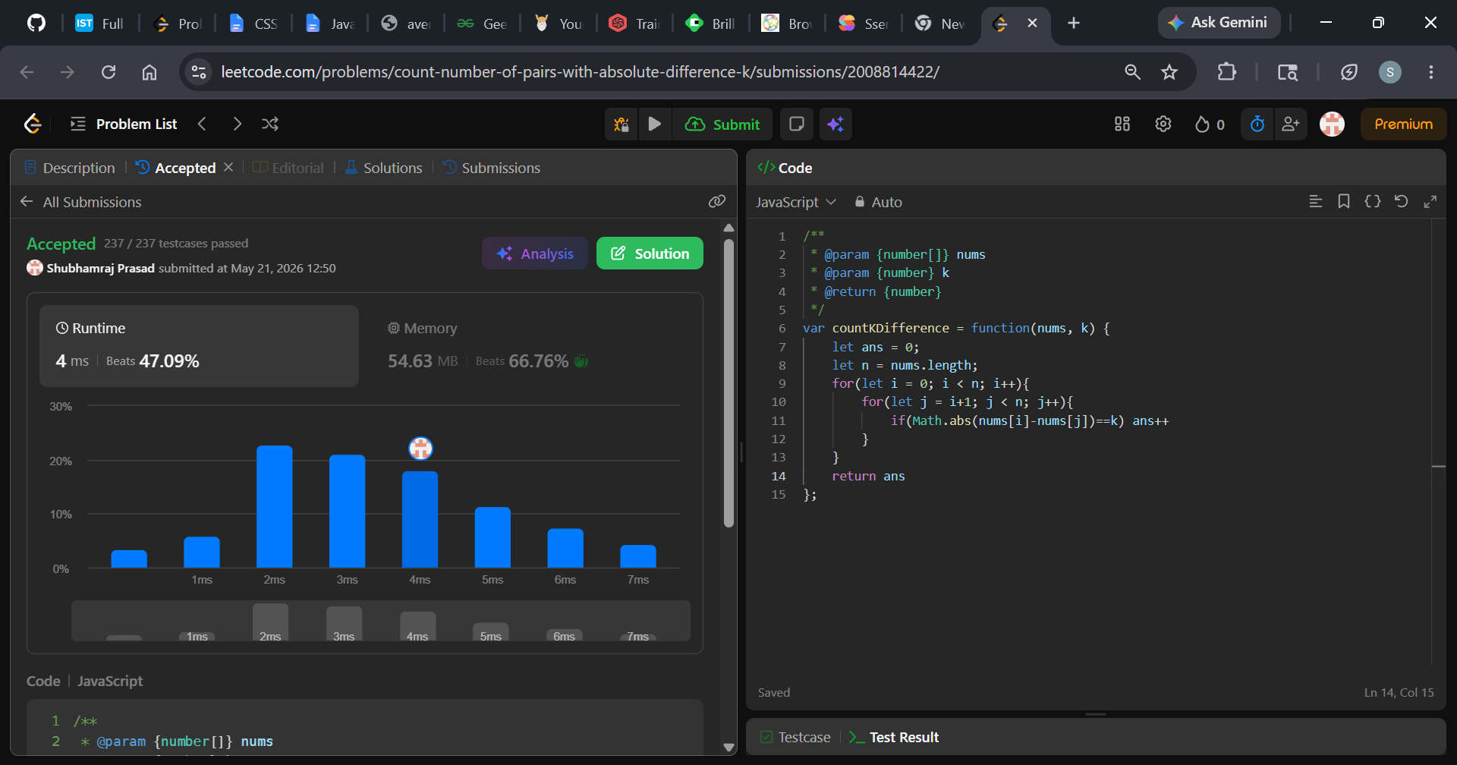
Description: -
- Time Complexity: O(N^2) because of the nested loops. If the array has 1,000 elements, it will execute the inner condition roughly 500,000 times.
- Space Complexity: O(1) constant space, because it only creates a couple of simple variables (ans, n, i, j) regardless of how large the array grows.
Explanation: -
This code uses a brute-force approach to solve the problem. It works by checking every possible pair of numbers in the array one by one to see if their absolute difference equals k.
Here is a step-by-step breakdown of how it works:
1. Initialization
JavaScript
let ans = 0;
let n = nums.length;
- ans: A counter variable initialized to 0. This will store the total number of valid pairs found.
- n: Stores the total length of the nums array so the loops know when to stop.

2. The Nested Loops (Checking Every Pair)
To find pairs, the code uses two loops. The trick here is how the indices i and j are set up to avoid checking the same pair twice or comparing a number with itself.
JavaScript
for (let i = 0; i < n; i++) {
for (let j = i + 1; j < n; j++) {
- Outer Loop (i): Picks the first number of the pair (nums[i]) and moves sequentially from the start of the array to the end.
- Inner Loop (j): Picks the second number of the pair (nums[j]). Because it starts at i + 1, it only looks at elements to the right of i. This completely prevents duplicate checks (like checking index (0, 1) and then checking (1, 0)).

3. The Condition and Counter
JavaScript
if (Math.abs(nums[i] - nums[j]) == k) ans++;
- nums[i] - nums[j]: Subtracts the second number from the first.
- Math.abs(...): Takes the absolute value of that subtraction. This ensures that the difference is always a positive number (e.g., both 1 - 3 = -2 and 3 - 1 = 2 become 2).
- == k: Checks if that absolute difference is exactly equal to k. If it is, ans++ increments our counter by 1.

4. Return the Result
JavaScript
return ans;
After both loops finish completely examining all unique pairs, the function returns the final value of ans.

Dry Run Example
If nums = [1, 2, 2, 1] and k = 1:
- i = 0 (nums[0] = 1):
  - Compare with j = 1 (2): $|1 - 2| = 1$ $\rightarrow$ Match! (ans = 1)
  - Compare with j = 2 (2): $|1 - 2| = 1$ $\rightarrow$ Match! (ans = 2)
  - Compare with j = 3 (1): $|1 - 1| = 0$ $\rightarrow$ No match.
- i = 1 (nums[1] = 2):
  - Compare with j = 2 (2): $|2 - 2| = 0$ $\rightarrow$ No match.
  - Compare with j = 3 (1): $|2 - 1| = 1$ $\rightarrow$ Match! (ans = 3)
- i = 2 (nums[2] = 2):
  - Compare with j = 3 (1): $|2 - 1| = 1$ $\rightarrow$ Match! (ans = 4)
Total pairs found = 4.

Question 3:- https://leetcode.com/problems/number-of-good-pairs/
Solution: - https://leetcode.com/problems/number-of-good-pairs/submissions/2008828996/
Screenshot:-
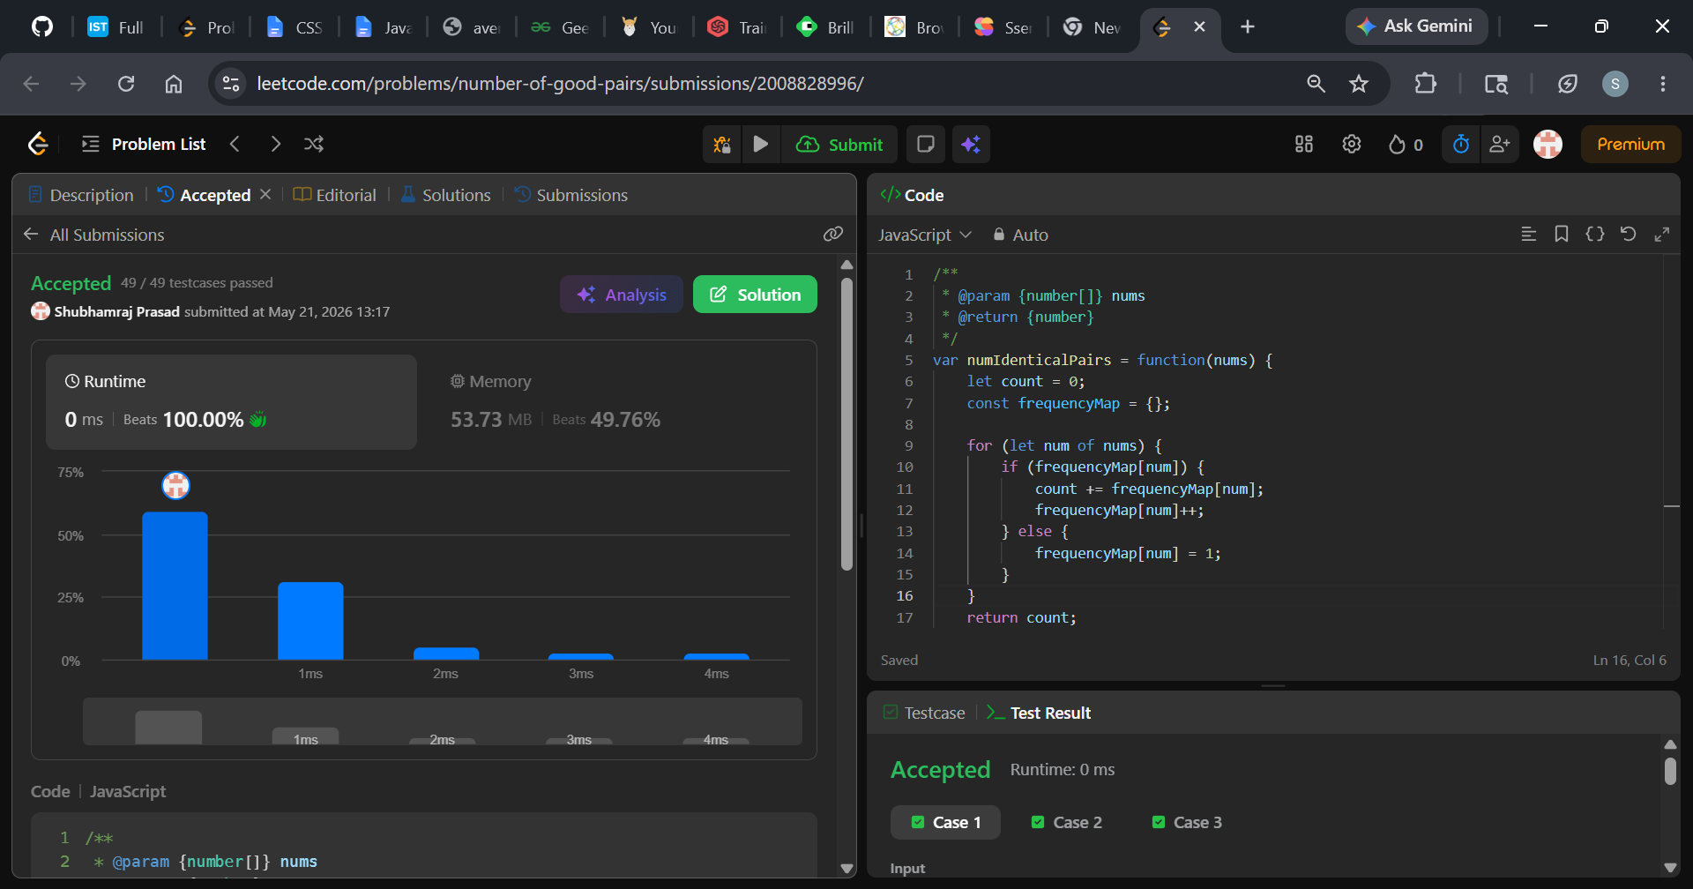
Description: -
- Time Complexity: O(n) The time complexity is linear, where n is the total number of elements in the nums array.
- Single Pass: The code uses a single for...of loop that visits each number in the array exactly once.
- Instant Lookups: Inside the loop, checking if a key exists in an object (if (frequencyMap[num])) and updating it takes O(1) constant time on average.
- Space Complexity: O(n) The space complexity is also linear, where n is the number of elements in the array.
- Memory Allocation: The code creates a new object (frequencyMap) to keep track of the counts.
- Worst-Case Scenario: If every single number in the input array is unique (for example, [1, 2, 3, 4, 5]), the map will grow to store an entry for every single element. Therefore, it will hold n distinct key-value pairs, using O(n) auxiliary memory.
Explanation: -
Here is a breakdown of exactly how the Hash Map approach works step-by-step.
The core secret to this method is looking backward. Instead of searching the whole array for matches, the code loops through the numbers one by one, keeping track of what it has already seen in a "history log" (frequencyMap).

Step-by-Step Walkthrough
Let's trace the code using the example array: nums = [1, 2, 3, 1, 1]
1. Initialization
JavaScript
let count = 0;
const frequencyMap = {};
- count will store our total number of good pairs.
- frequencyMap starts empty: {}.

2. The Loop Begins
- First Element (num = 1):
  - Have we seen 1 before? No (frequencyMap[1] is undefined).
  - Action: Go to the else block and record that we've seen it once.
  - State: count = 0, frequencyMap = { 1: 1 }
- Second Element (num = 2):
  - Have we seen 2 before? No.
  - Action: Record it in the map.
  - State: count = 0, frequencyMap = { 1: 1, 2: 1 }
- Third Element (num = 3):
  - Have we seen 3 before? No.
  - Action: Record it in the map.
  - State: count = 0, frequencyMap = { 1: 1, 2: 1, 3: 1 }

3. The Magic Happens (Finding Matches)
- Fourth Element (num = 1):
  - Have we seen 1 before? Yes! Look at the map: frequencyMap[1] is currently 1.
  - The Logic: Because there is already one 1 sitting behind us in the array, this new 1 can pair up with it to form 1 new good pair.
  - Action: 1. Add that 1 to our count (count += 1). 2. Increment the frequency of 1 in our map because we have now seen it twice.
  - State: count = 1, frequencyMap = { 1: 2, 2: 1, 3: 1 }
- Fifth Element (num = 1):
  - Have we seen 1 before? Yes! Look at the map: frequencyMap[1] is now 2.
  - The Logic: Because there are two separate 1s sitting behind us in the array, this third 1 can pair up with both of them individually. That forms 2 brand new good pairs.
  - Action:
    - Add those 2 pairs to our count (count += 2).
    - Update the map to show we've now seen 1 three times.
  - State: count = 3, frequencyMap = { 1: 3, 2: 1, 3: 1 }

Question 4:- https://leetcode.com/problems/shuffle-the-array/description/
Solution: - https://leetcode.com/problems/shuffle-the-array/submissions/2008903506/
Screenshot:-
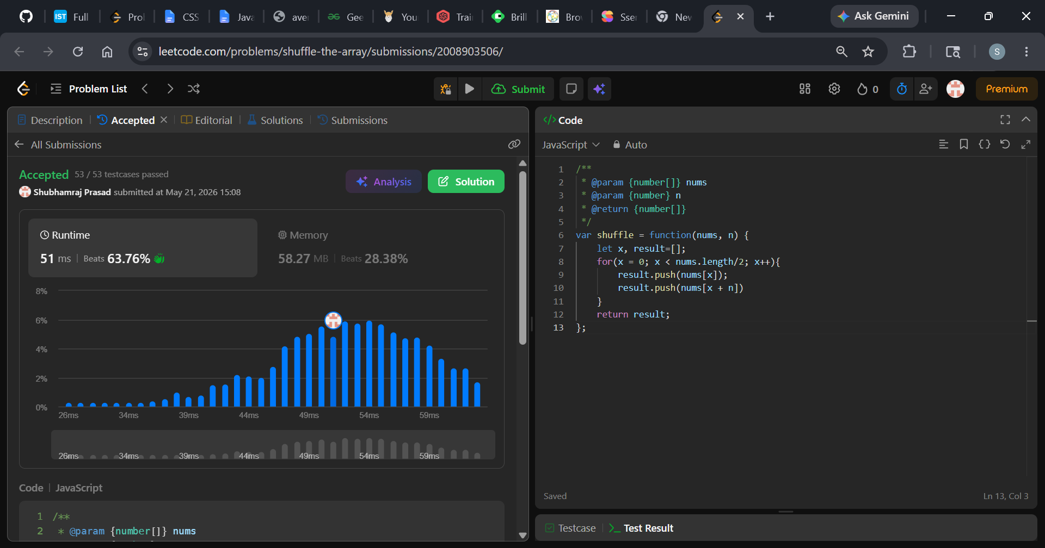
Description: -
- Time Complexity: O(n) — The loop runs exactly $n$ times, making it highly efficient.
- Space Complexity: O(n) — It creates a brand new array (result) that scales linearly with the size of the input.
Explanation: -
This JavaScript function solves the Shuffle the Array problem. It takes an array nums of $2n$ elements in the form $[x_1, x_2, ..., x_n, y_1, y_2, ..., y_n]$ and rearranges it into the format $[x_1, y_1, x_2, y_2, ..., x_n, y_n]$.
Here is a step-by-step breakdown of how this exact code works:

Code Breakdown
- let x, result = [];
This initializes an empty array named result to store the final shuffled elements and declares x as a loop counter variable.
- for(x = 0; x < nums.length / 2; x++)
The loop only runs through the first half of the array (since nums.length / 2 is exactly equal to n).
  - x acts as the index for the $x$-elements (the first half).
- result.push(nums[x]);
In every iteration, it grabs the element from the first half of the array (nums[x]) and pushes it into result.
- result.push(nums[x + n])
Immediately after, it looks exactly n elements ahead to grab the corresponding element from the second half (nums[x + n]) and pushes it into result.
- return result;
Once the loop finishes processing the first half, the result array is fully populated and returned.

Dry Run Example
Let's say nums = [2, 5, 1, 3, 4, 7] and n = 3.
The array length is 6, so the loop runs while x < 3 (indices 0, 1, and 2).
- Iteration 1 (x = 0):
  - Pushes nums[0] ($\mathbf{2}$) $\rightarrow$ result = [2]
  - Pushes nums[0 + 3] which is nums[3] ($\mathbf{3}$) $\rightarrow$ result = [2, 3]
- Iteration 2 (x = 1):
  - Pushes nums[1] ($\mathbf{5}$) $\rightarrow$ result = [2, 3, 5]
  - Pushes nums[1 + 3] which is nums[4] ($\mathbf{4}$) $\rightarrow$ result = [2, 3, 5, 4]
- Iteration 3 (x = 2):
  - Pushes nums[2] ($\mathbf{1}$) $\rightarrow$ result = [2, 3, 5, 4, 1]
  - Pushes nums[2 + 3] which is nums[5] ($\mathbf{7}$) $\rightarrow$ result = [2, 3, 5, 4, 1, 7]
Final Return: [2, 3, 5, 4, 1, 7]

Question 5:- https://leetcode.com/problems/maximum-subarray/description/
Solution: - https://leetcode.com/problems/maximum-subarray/submissions/2008913138/
Screenshot:-
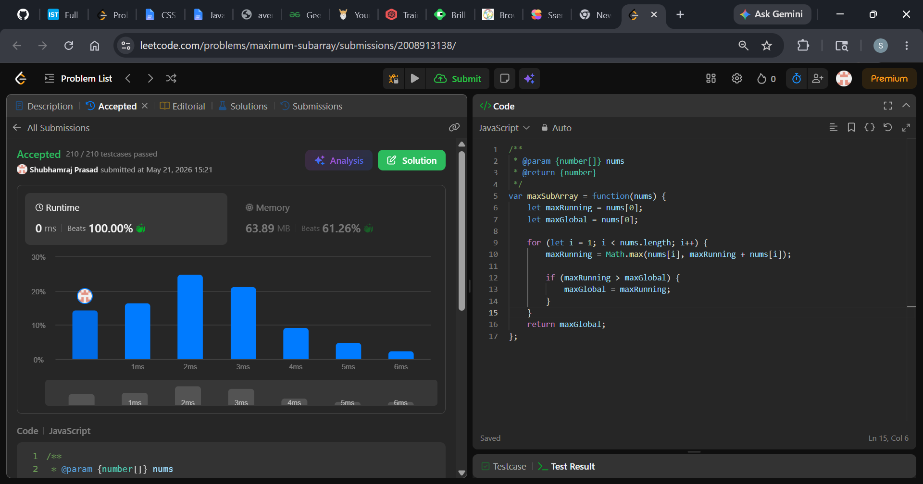
Description: -
- Time Complexity: O(n) - The algorithm uses a single for loop to iterate through the array exactly once. Inside the loop, it only performs constant-time O(1) operations (addition and Math.max). Thus, execution time scales linearly with the input size.
- Space Complexity: O(1) - It only uses two variables (maxRunning and maxGlobal) to track the sums in place. No extra data structures or memory scale with the input size.
Explanation: -
53. Maximum Subarray, a classic interview problem. The absolute best way to solve this in $O(n)$ time complexity and $O(1)$ space complexity is by using Kadane's Algorithm.
To understand this code, it helps to realize that it solves a classic problem: finding the contiguous subarray within an array of numbers that has the largest sum. It does this using Kadane's Algorithm, which finds the answer in a single pass.
Here is a step-by-step breakdown of how the code achieves this.

1. Initialization
JavaScript
let maxRunning = nums[0];
let maxGlobal = nums[0];
Before looping, the code initializes two variables using the very first element of the array (nums[0]):
- maxRunning: This tracks the maximum sum of a subarray that must end at the current position you are looking at.
- maxGlobal: This acts as a scoreboard. It stores the absolute highest subarray sum found anywhere in the array so far.

2. The Loop
JavaScript
for (let i = 1; i < nums.length; i++) {
The loop starts at index 1 (the second element) because index 0 was already used to initialize our variables. It visits every element in the array exactly once.

3. The Core Logic (The Choice)
JavaScript
maxRunning = Math.max(nums[i], maxRunning + nums[i]);
This is the heart of Kadane's algorithm. At every single number (nums[i]), you have to make a choice. Is it better to:
- Extend the existing subarray? (Take the previous running sum and add the current number: maxRunning + nums[i])
- Start a brand new subarray? (Throw away the past and just start fresh with the current number: nums[i])
Math.max() compares these two choices and keeps whichever one yields a larger sum.
Why would you start fresh? If maxRunning has become a negative number, adding it to the current number will only drag the current number down. It's better to abandon the past and restart the subarray from the current element.

4. Updating the Scoreboard
JavaScript
if (maxRunning > maxGlobal) {
maxGlobal = maxRunning;
}
After calculating the best possible subarray sum ending at the current index (maxRunning), we check if it beat our all-time high score (maxGlobal). If it did, we update maxGlobal.

5. The Return
JavaScript
return maxGlobal;
Once the loop finishes, maxGlobal holds the maximum sum found across the entire array, and the function returns it.

A Quick Walkthrough Example
Imagine the input is nums = [-2, 3, -1].
- Initialization: * maxRunning = -2, maxGlobal = -2
- Index 1 (nums[1] = 3):
  - maxRunning = Math.max(3, -2 + 3) $\rightarrow$ Math.max(3, 1) $\rightarrow$ 3 (Starting fresh was better than extending the negative past!)
  - Is maxRunning (3) > maxGlobal (-2)? Yes. maxGlobal = 3.
- Index 2 (nums[2] = -1):
  - maxRunning = Math.max(-1, 3 + -1) $\rightarrow$ Math.max(-1, 2) $\rightarrow$ 2 (Extending was better than starting fresh.)
  - Is maxRunning (2) > maxGlobal (3)? No. maxGlobal stays 3.
Final Return: 3 (which comes from the subarray [3]).

Question 6:- https://leetcode.com/problems/binary-search/description/
Solution: - https://leetcode.com/problems/binary-search/submissions/2009137879/
Screenshot:-
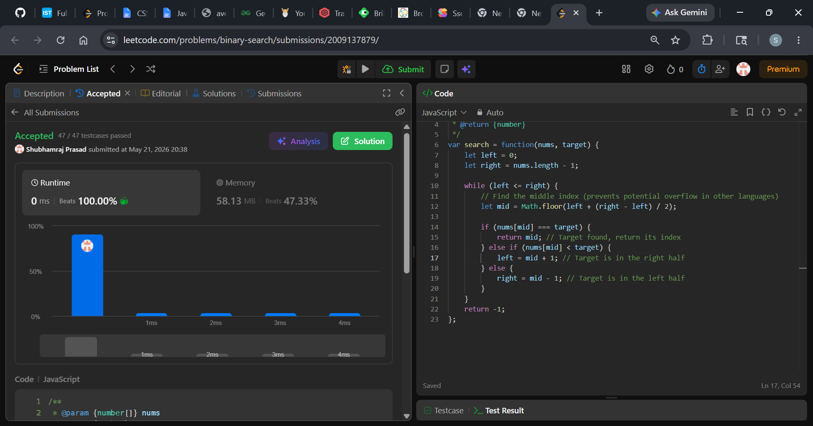
Description: -
- Time Complexity: O(log n) because the search space is cut in half with every single iteration.
- Space Complexity: O(1) as it only uses a few pointers and modifies nothing in memory.
Explanation: -
JavaScript implementation of the Binary Search algorithm works:
The Core Idea
Binary search works on a divide-and-conquer principle. Because the input array (nums) is already sorted in ascending order, we don't need to check every single number from left to right. Instead, we look at the middle element:
- If the middle element is exactly what we are looking for, we are done.
- If our target is larger than the middle element, the target must be in the right half. We discard the left half.
- If our target is smaller than the middle element, the target must be in the left half. We discard the right half.

Step-by-Step Code Walkthrough
1. Setting up the Search Boundaries
JavaScript
let left = 0;
let right = nums.length - 1;
We define two pointers, left and right, which represent the current "window" of the array we are searching through. At the start, the window spans the entire array (from index 0 to the very last index).
2. The Loop Condition
JavaScript
while (left <= right) {
The search continues as long as our search window is valid (left is less than or equal to right). If left becomes greater than right, it means the window has collapsed to empty, and the target is not in the array.
3. Finding the Middle Index
JavaScript
let mid = Math.floor(left + (right - left) / 2);
We calculate the midpoint of our current window.
Note on the math: Writing it as left + (right - left) / 2 instead of (left + right) / 2 is a standard programming habit. It prevents an "integer overflow" error in languages like C++ or Java if the numbers are massive, though JavaScript handles large numbers safely as floats. Math.floor() ensures we get a whole integer index.
4. The Three-Way Decision
JavaScript
if (nums[mid] === target) {
return mid;
}
- Scenario A (Match): If the value at the middle index nums[mid] matches our target, we successfully found it! We immediately return the index mid.
JavaScript
else if (nums[mid] < target) {
left = mid + 1;
}
- Scenario B (Target is larger): If the middle value is smaller than our target (e.g., the middle is 5 but we want 9), the target must be on the right side. We shift our left pointer to mid + 1, cutting the left half of the array completely out of the equation.
JavaScript
else {
right = mid - 1;
}
- Scenario C (Target is smaller): If the middle value is larger than our target (e.g., the middle is 5 but we want 2), the target must be on the left side. We shift our right pointer to mid - 1, discarding the right half.
5. Fallback Failure Case
JavaScript
return -1;
If the while loop finishes because left > right without ever hitting the return mid statement, it means the target does not exist in the array. Per the problem rules, we return -1.

Why this is highly efficient: $O(\log n)$
Every time the loop runs and doesn't find a match, it eliminates half of the remaining numbers.
- If you have $6$ elements, it takes at most around $3$ steps.
- If you have $1,000,000$ elements, a linear search might take $1,000,000$ steps, but binary search will find it (or realize it's missing) in at most 20 steps.

